ParentActivity

Letter

**Today, we recommend** the focus book, ***“Fledging”*** by Robert J. Blake. In class, wetalk about sequencing, what comes first, second, and third.

**At home** have your child follow directions by having them help you put groceries away. An example of this would be to ask your child to put the can of corn in the pantry, put the milk on the top shelf of the refrigerator and put the ice cream in the freezer.

**To extend** the activity give your child multiple directions at one time that they need to follow in sequential order, such as getting a drink you would say First go get the a cup, second put the cup on the table, third go and get the milk, fourth pour the milk into the cup. This activity will increase learning objective 8 under language. listens to and understands increasingly complex language.

***\*\*\*Please remember to read aloud to your child daily. We recommend reading a minimum of 3 hours a week with your child. C:\Users\BCCAP- Head Start\AppData\Local\Microsoft\Windows\Temporary Internet Files\Content.IE5\VAOL3GO4\MC900437791[1].wmf***

**The PAL letters are developed to support your child’s academic/social emotional progress and related to the programs School Readiness goals.**

Friday**: __________________**Return by Thursday: ___________**________**

Child’s Name: _______________________________________________________________

Parent Name: _______________________________________________________________

Rate this activity from 1-5, circle your rating (5= highest rating): **1 2 3 4 5**

Comments about the activity: ________________________________________________________________

I agree that completing the at home activity and reading aloud to my child is equivalent to four hours volunteer time for the week.

**Parent’s Signature:** ____________________________ Room:**___________________**

[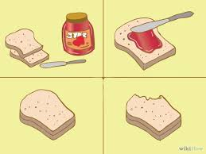](http://www.google.com/imgres?imgurl=http://pad1.whstatic.com/images/thumb/c/c5/Teach-Preschool-Children-Sequencing-Step-3.jpg/670px-Teach-Preschool-Children-Sequencing-Step-3.jpg&imgrefurl=http://www.wikihow.com/Teach-Sequencing-to-Preschool-Children&h=503&w=670&tbnid=y9kpW1XVTSj7fM:&docid=gfe3s2ojNNVpsM&ei=Xws9VtC2Horq-AG46bmYDw&tbm=isch&ved=0CCYQMygJMAlqFQoTCJDip7bP_MgCFQo1PgoduHQO8w)

[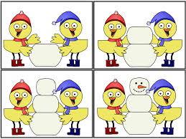](http://www.google.com/imgres?imgurl=http://2.bp.blogspot.com/-P9pmaGrH4lU/TwXcGrQUjII/AAAAAAAAAJI/DNDMMMJcnVM/s1600/winterbirdsequence1.gif&imgrefurl=http://a-childs-place.blogspot.com/2012_01_01_archive.html&h=720&w=960&tbnid=-dUeUdN4ueCMHM:&docid=LzoV6fuq5WYlHM&ei=Jgo9VtmTHoPZ-QGL77OABw&tbm=isch&ved=0CEAQMygZMBlqFQoTCNm-h6HO_MgCFYNsPgodi_cMcA)