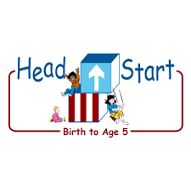**PARENT ACTIVITY LETTER**

**CHILD’S NAME: ______________________**

**RATETHIS ACTIVITY FROM 1-5, CIRCLE YOUR RATING (5=HIGHEST RATING): 1 2 3 4 5**

**COMMENTS ABOUT THE ACTIVITY:**

**_______________________________________________________________________________________________________________________**

**\*\*At this time while your child is learning at home, there’s no need to return this PAL to school, but you can keep it to go over with your child as a follow-up learning experience.**

**\*\*Remember to have fun learning together!**

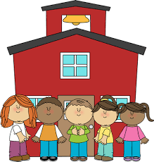

**REMOTE lEARNING ACTIVITIES**

*The PAL Letters are developed to support your child’s academic/social-emotional progress and are related to the program’s School Readiness goals.*

**FOCUS BOOK**

**Recommended Read Aloud**: Changes, Changes: Cambios, Cambios By: Pat Hutchins

***\*\*\*Please remember to read aloud to your child daily. We recommend reading a minimum of 3 hours per week with your child.***

**Why It’s Important:**

Physical development shows your child how to grasp and manipulate objects during this experience. Gross motor is a great way to stay active and healthy. It encourages movement and the ability to build skills.

**Primary Objectives for the activity**

This activity encourages objective 7a fine motor skills and strength

**At home, invite your child to:** join you in creating bridges and tunnels. You and your child sit on the floor with your legs straight out. Explain that their legs make a bridge and when they lift up their knees; they make a tunnel. Ask, “What could move over our bridge and go under the tunnel?” Also, use hand motions to act out the following chant: We lower the bridge and car drives over. We raise the bridge and the shark swims under.

**To extend this activity:** Invite children to pass a toy vehicle over the bridge or through the tunnel and ask them to think of different ways things can move over or under the bridge. (The airplane flies over or the boat sails under)