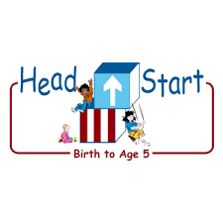**PARENT ACTIVITY LETTER**

**CHILD’S NAME: ______________________**

**RATETHIS ACTIVITY FROM 1-5, CIRCLE YOUR RATING (5=HIGHEST RATING): 1 2 3 4 5**

**COMMENTS ABOUT THE ACTIVITY:**

**_______________________________________________________________________________________________________________________**

**\*\*At this time while your child is learning at home, there’s no need to return this PAL to school, but you can keep it to go over with your child as a follow-up learning experience.**

**\*\*Remember to have fun learning together!**

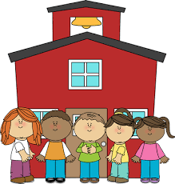

**REMOTE lEARNING ACTIVITIES**

*The PAL Letters are developed to support your child’s academic/social-emotional progress and are related to the program’s School Readiness goals.*

**FOCUS BOOK**

**Recommended Read Aloud**: The Doorbell Rang by Pat Hutchins

***\*\*\*Please remember to read aloud to your child daily. We recommend reading a minimum of 3 hours per week with your child.***

**Why It’s Important:**

Providing your child with a goal to focus on while she practices her gross motor skills may encourage her to move more readily, even with adult support. Counting each step slowly is a way to support your child’s efforts to move purposefully.

**Primary Objectives for the activity**

4. Demonstrates traveling skills 20a. Counts

**At home, invite your child to:** count the number of steps they take while moving from one area of the room to another. You can do this together as you hold your child’s hand or provide other support. Acknowledge their movements. “Walking upstairs is hard work. You are really using your strong leg muscles today. Count when going up and down stairs, through doors, etc. “One, two, three, four, five, six. Six steps to get to the sink.”

**To extend this activity:** Repeat the paths that were already taken. Ask your child if they can remember the number of steps it took the last time. Count again to see if the number matches. “It took us six steps to get to the sink. Let’s see how many steps it takes to get back to the chair.”